

**Senior Design Project I**

**Project Report:**

**Autonomous Ocean Nutrient Analyzer**

ME 195A Section 06

Instructor: Edward Cydzik

Authors: A. Silva, C. Hayes, T. Hunter, T. Ly

Department of Mechanical Engineering, San José State University

December 5th, 2021

**TEAM PICS AND BACKGROUND INFORMATION GOES HERE**

**Abstract**

* Purpose
* Problem
* Solution

**Acknowledgements**

**THANKS TO NOT ONLY THE THE ADVISORS BUT DR> JIANG AND DU FOR THE HELP**

**Executive Summary** **2**

**Chapter 1- Introduction** **2**

Problem Definition 2

Project Objectives and Specification 3

Design Specifications 4

Current Status (Literature Review) 4

Figure 1 4

Relevant Research 6

Significance of Project and Challenges 7

Team Work 7

Gantt Chart 8

Specifications 8

**Chapter 2** **9**

Theoretical Background 9

Figure 2 9

The basic setup of the tetimetry analysis on a wet bench. Photo courtesy of www.qph.fs.quoracdn.ne 9

**Chapter 3** **12**

Design Overview 12

Enclosure and Housings 13

Figure 3 13

Proposed enclosure for instrument 13

Figure 4 13

Pump fixtures inside the enclosure 13

Mechatronic Systems 14

Figure 5 15

**Chapter 4** **15**

Testing Results and Analyses 15

Conclusions and Future Work 16

Description 16

**Deliverable(s)** **18**

**References** **20**

**Appendices** **23**

Appendix A: Gantt Chart 23

Appendix B: Various Elements of Benchtop version 24

# Executive Summary

**PLACE WORDING HERE**

In order to measure phosphate levels in the sea water of Moss Landing, the Moss Landing Marine Laboratory would be required to purchase up to 35000 dollar analyzer machines. In order to cut costs, the Laboratory created a project to build a microcontroller based machine that integrates the same components that, according to the lab, can save tens of thousands of dollars.

All major hardware was provided for the project with the exception of the microcontroller. This included two aspirating/dispensing step motors, a rotary valve connected to a motor, a communication board, spectrophotometer, and a power supply.

The first task was to choose a suitable microcontroller that had sufficient speed , memory, and storage. The Raspberry Pi 4 was chosen as it provided exceptional performance in all three criteria.

The next step was to establish communication between the microcontroller and the hardware. The hardware provided included a communication board that handled power delivery and communication between the components and a chipset. It was known that the chip could be interfaced via usb connection using a windows computer. In order to simulate the connection, the pySerial library was downloaded on the Raspberry Pi. This established a serial object that could be used to send encoded strings to the chipset that would handle communication to the motors.

The motors feature a controller integrated into them, and can operate the motor via proprietary commands. By using the communication board with the serial object in the project program, it is possible to encode the proprietary commands in the python script and send it to the communication board, which then sends the command to the motor controller and operates the motor. This is the main method for controlling both the valve and the motor of the project.

The script was then designed based on the sequence provided by the laboratory. The motors and valves successfully changed ports and dispensed/aspirated the proper amounts.

The final step in recreating the commercial

# 

# Chapter 1- Introduction

## Problem Definition

In the waters of Monterey bay in California exists a vast abundance of oceanic diversity. These nutrient rich waters contain an ecosystem which includes 33 species of marine animals, 94 species of seabirds, as well as 345 species of fish [1]. To maintain this ecosystem one needs to better understand the underlying parameters that impact it. Two of these parameters are nitrogen and phosphorus levels in the ocean. These two elements are essential for plant life, however when there is an abundance of dissolved nutrients in water it can produce the phenomenon known as eutrophication, which results in the reduction of dissolved oxygen in water [2]. This influx of nutrients produces massive algae growth, which is detrimental to the ecosystem. Different strains of algae produce different byproducts as a result of massive growth, the most devastating effects can be red tides, oxygen depletion, poisonous toxins, as well as fish gill damage [3]. One main culprit of this influx of phosphorus and nitrate levels is caused by the use of fertilizers for large agriculture businesses. The fertilizers used contain nitrates and phosphates which help crops grow but this overuse can reach into the waterways and throw off the balance of whole ecosystems. Therefore a way to monitor the compounds is essential. Monterey Bay is home not only to a biodiverse ecosystem, it is also a vast agricultural hub in the U.S. Monterey county feeds the nation by supplying 61% of leaf lettuce, 57% of celery, 56% head lettuce, 48% of broccoli, 38% spinach, 30% cauliflower, 28% strawberries, and 3.6% of wines grapes across 267,873 acres of land [4]. Therefore there is a need for monitoring the levels of nitrate and phosphate closely.

Nutrient analyzers are instruments which are capable of measuring concentrations of certain nutrients. Most measurements of nutrients are done by taking water samples for later analysis at the lab. One method of a nutrient analyzer is using a wet chemical process. The process draws in sample water on the device which is mixed with reagents, resulting in a color complex. Using this complex in conjunction with a light source, one can use a spectrometer to measure the concentration of target nutrients [5]. Many nutrients can be measured such as dissolved nitrate, ammonium phosphate and silicate.

Deployable instruments are expensive, in the tens of thousands of dollars, and units in the field are deployed sparsely. The nutrient analyzer project aims to lower this price by not commercializing it. Instead, it will be made available to everyone who wants to build it. This will provide increased monitoring of water supplies. This greatly increases the equality factor because it provides everyone access to water monitoring, not just those that can afford it. Socially it can impact people’s ways of life by ensuring water quality standards. Many big agricultural businesses use fertilizers and pesticides which contain high levels of phosphates, cattle farming has manure which also contain high levels of nitrogen. When these are not monitored, it destroys marine wildlife and has dire consequences for humans as well. The normal phosphorus level is 2.5 to 4.5mg/dl, however when these are elevated, they can create changes in the body that pull calcium from the bones which leads to dangerous calcium deposits in blood vessels, lungs, eyes, and heart which can lead to increase chance of heart attack and stroke [6]. Having monitoring sites that are farther upstream to the source of pollution, the instrument can help pinpoint the source of pollution and create more accountability to those offenders of the laws that are put in place. Unlike more developed areas like larger cities which have large treatment facilities, areas surrounding big Ag and industry are more of the lower class farm workers which rely on underground water aquifers for their clean water.

## Project Objectives and Specification

The primary objective of this project is to design and implement an autonomous version of the current benchtop nutrient analyzer that is in use by the Moss Landing Marine Laboratory. This Primary objective will be achieved by implementing a microcontroller into the current design to bypass the communications board and software that is used. The draw back now is that a desktop or laptop computer must be used in order to run the system and analyze data. This makes for a restriction in the deployable process. Currently samples are taken from the field and brought back to the lab for analysis which is time consuming. Furthermore, samples are just instances at specific times and do not provide real time data collection capabilities. By implementing a microcontroller data will be collected from the field in real time to monitor water quality in terms of phosphate levels. These time series will then be stored on the drive of the controller where a researcher can access it periodically. A sub-objective of this project, if time permits, will be to design a storage container to house the two pumps, the servo valve, spectrometer, reagents, waste bag, and power supply unit.

## Design Specifications

This project is focused on the implementation of an autonomous sea water analyzer that will be used to monitor water quality at the Moss Landing Research Center. The design specifications will be to take the currently working desktop version of the analyzer and create a self-contained one.

## Current Status (Literature Review)

Nutrient analyzers are used in abundance throughout many fields of industry. For example, they are installed in wastewater treatment plants to ensure regulatory compliance by controlling the outlets of wastewater inside of the facility. By monitoring the nutrient levels they help to optimize the aeration control and precipitant dosing during biological treatment of wastewater, and monitor denitrification to support safe drinking water, mineral water and process water [7]. Liquid analysis is essential in many industries to achieve high quality and efficient process control. One of the most important aspects to analysis is the colormetric measuring principle and photometric principle, which is employed in the current version used by MLML. The instrument in use is GlobalFIAs miniSIA-2 [8].

### Figure 1

The miniSIA-2 analyzer with Chem-on-Valve manifold courtesy www.globalfia.com

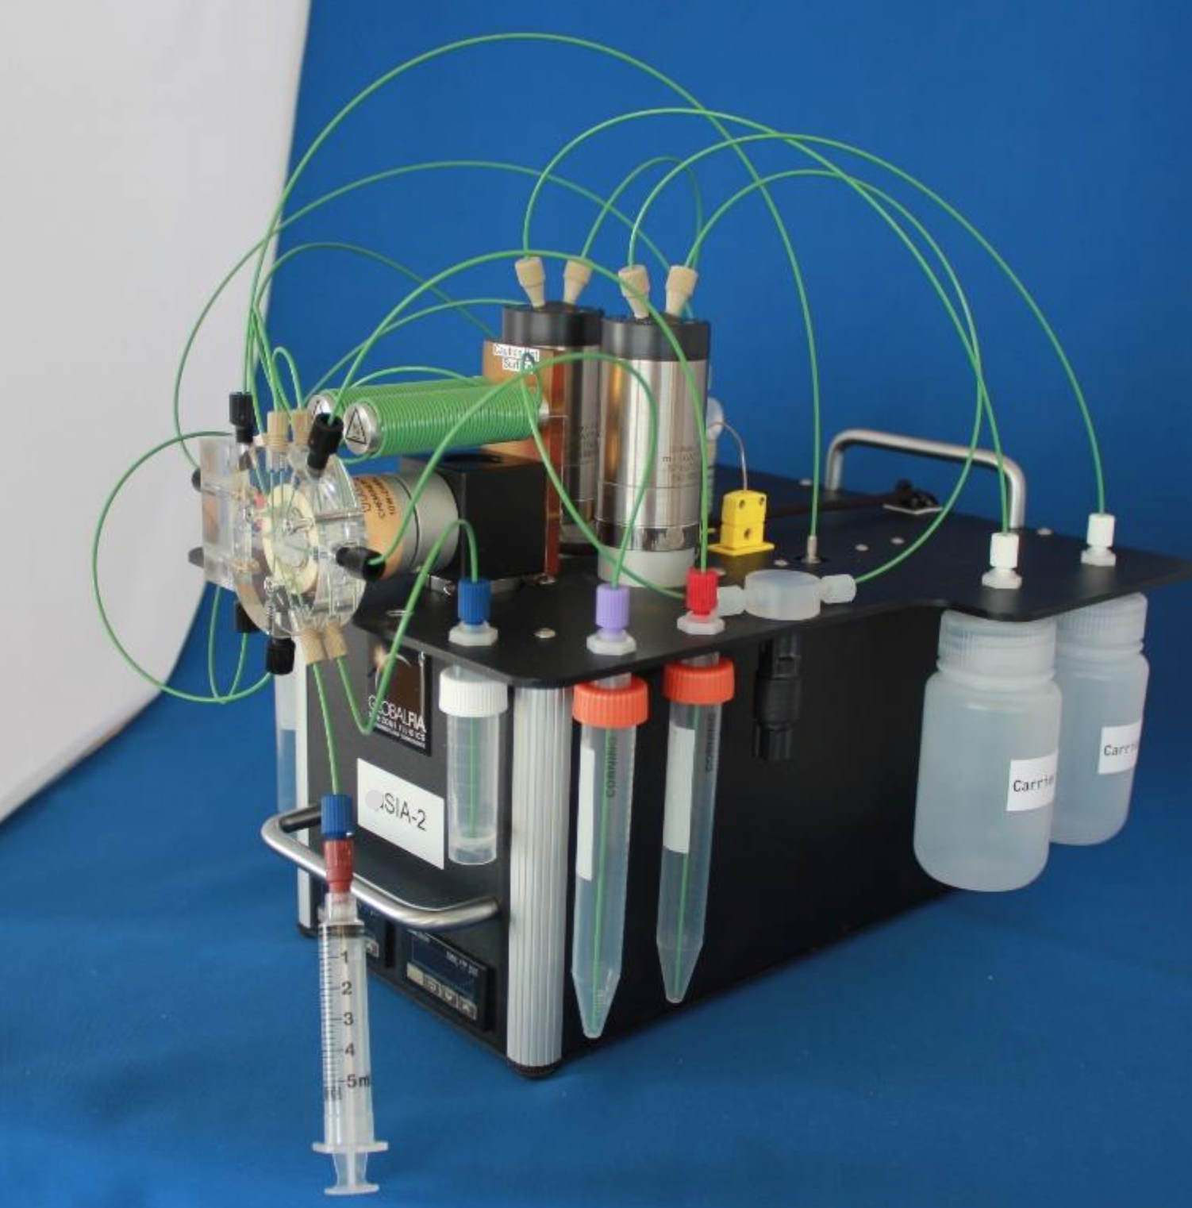

From researching GlobalFIA’s website we learned that this system is equipped with two milliGAT pumps coupled with heating coils, which control the speed of the reagent/sample mixing. Tubes running from these coils meet at the center of the Chem-onValve (VOC). The valve and pumps are controlled through the use of an Mdrive-17 plus microstepper motor, which allows for precision control through its high resolution.One of the main advantages of this type of setup is that it allows for simultaneous flow control with bi-directional movement of fluid between the pumps. This coupled with the multiport valve allows for an enclosed movement of reagents and samples which reduces the risk of outside contamination like when assaying on a wet bench. However, there is one drawback to this system in that if the pumps are not under precise control, one can easily contaminate the sample reservoir. If one pump stops aspirating before the second which is dispensing, it can create reverse flow leading to the sample line.

Through a sequence of steps this instrument mixes reagents and samples which are then moved through the system to the Spectrometer for analysis. MLML currently uses this process developed by GlobalFIA to analyze samples. While their company uses its own programming through their Flo-ZF software, it is a robust application that can be set to the needs of the consumer. One is allowed to create their own set of commands and controls for the minSIA-2 to suit their needs. The researchers at MLML have spent the last year and a half creating their own chemistry to detect phosphate concentrations in their sample collected. One of the assistant professors at MLML, Maxime Grand, and his colleagues created their own chemical assay to detect phosphate concentrations with repeatable results.

## Relevant Research

It was important to conduct thorough research into the driving principles behind our project goals. Everyone on the team has a background in engineering with only surface level understanding of chemistry as articulated in our major requirements. This project is deeply entrenched in principles in organic chemistry, and more specifically, organic ocean chemistry. The 24-step assay used for capturing data required us to develop a conceptual background in this field to better assess the problem. We wanted to see what solutions others had made in the field and a focus on previously proven methods of nutrient detection and quantification was enacted; resulting in an abundance of information. A method of detection known as the molybdenum blue method as described by N. Ibnul et. al. details “the American Public Health Association (APHA) approved method for the detection and quantification of phosphate in water. The standard molybdenum blue method, APHA 4500 PE has a detection limit of 30 μgL−1 phosphate (10 μgL−1 phosphorus) in freshwater with a 5 cm cuvette,” [9]. This study focuses on freshwater phosphate samples, which is the exact same chemical assay used for seawater, in that fresh and sea water produce identical results regardless of the two mediums. The overall process and the emphasis on following a method in accordance with the APHA was determined to be important. Our project is grounded in sustainability and it's paramount that our solution reflects that. Defining result expectations was salient for our research as well. We can see from the presented data that we have a resolution of 30 micrograms per liter for phosphate anions and a resolution as high as 10 micrograms per liter for phosphorus. We used this to characterize our experiment expectations for the max limit of accuracy of data values we will capture.

One of the project's most lucrative goals is the ability to massively increase the rate of data collection. Right now, the current rate of data capture for the bench top setup is one sample every 3.5 min. However, the more samples taken, the more work will be required for collecting samples in the field to bring back to the lab. Legiret et. al. presents an experimental set that was capable of creating a “measurement frequency [that] was configurable with a sampling throughput of up to 20 samples per hour,” [10]. The set up was also “[a] portable micro-analytical system [which] has a low reagent requirement (340 μL per sample) and power consumption (756 J per sample), and has allowed accurate high resolution measurements of soluble reactive phosphorus in seawater,” [10]. A portable solution that will be deployed for extended periods of time is going to require energy management, reagent management, and data capture protocol. This research demonstrates that it is possible for seawater applications and further characterizes energy expectations per sample and reagent used per sample. These values are key to our initial design, allowing us to approximate what type of requirements we are going to need to meet. Our goal of measuring one sample every 30 minutes for 30 days. Where Legiret et. al showcases a high frequency data capture solution, we are looking for a more robust, long term setup. While the above research indicates that sampling as fast as 20 samples per hour is possible, it is not detailed how long this module lasts in the field.

The research presented above shows solutions to problems very similar to our own. Characterizing how fine of a measurement we can make, how often, energy consumption per sample and reagent used per sample enables us to fill in the blanks of some of our design parameters. This research gave us confidence that a portable nutrient analyzer is feasible within the scope of our project and aided in the advancement of our design.

## Significance of Project and Challenges

This project offers multiple avenues of significance as well as its own unique set of challenges. Developing a deployable nutrient analysis within the framework of open source technology offers wide access to the scientific community. Water quality is imperative and commercial options often exceed what research is capable of funding. We are removing barriers to entry for measuring environmental issues. With the emphasis on our project being able to measure agricultural run off we are working to provide technology that combats environmental hazards and promotes sustainability. All of us convergently seeked this project out because of a love of nature and maintaining balance within our natural world. As engineers we have a significant impact over how the world advances and with the right effort we can provide alternatives to the status quo that promotes sustainability and democratizing water quality analysis.

Our project does come with its challenges. Working within the constraints of the pandemic has bottlenecked our access to parts and manufacturing capabilities. We have combatted this by reallocating time and effort to areas where we can make an impact on the project, taking on tasks that were scheduled for next semester. The issue of integrating commercial proprietary equipment with open source interfacing has proven to be a challenge. Getting in contact with GlobalFIA, the company that provides the equipment we are implementing, has made non-commercial interfacing a challenge. It was discovered that the wiring for communications was not the same as the documentation provided. We are going through the process of root cause analysis to determine what interfacing protocol we need to develop for communicating with the set up.

## 

## Team Work

Each of us were tasked with specific sections of the project ranging from pure programming to bill of material analysis. Each of us worked on everything but had focus. Tracy was responsible for researching microcontrollers, developing preliminary CAD design and conducting a literature review. This was conducted through standard streams of research, software packages like SolidWorks as well as collaboration with the rest of the team. Andrew has been tackling the majority of communication protocol troubleshooting. This is being conducted through conferring with documentation and actual analysis of the system in person. Timothy has undertaken the majority of the control system design study as well as programming methodology study. Cameron has assisted in the development of our bill of materials, alternative enclosure study, as well as researching options for open source publishing. Complimentary to all of our independent research, we have all contributed to class deliverables in a fair manner.

## Gantt Chart

Our Gantt chart does a great job visualizing our design process. We are looking forward to some key tasks on our Gantt chart for next semester. Some of the highlights are integrating piping into the enclosure and final testing of our mechatronic control system.

Note: See Gantt Chart in Appendix A for a visual of the current timeline established for the project.

## Specifications

The MLML has requested the following specification of the instrument. Primarily that it can run autonomously and continuously, for as long as it has enough substrate. This requires multiple feedback loops to ensure the instrument does not perform incorrectly and contaminate the analysis. Secondarily, the instrument needs to be able to perform the calculations on its own and be able to record the findings. In order to make the calculations the device must be able to be calibrated by the user in situ. The data logged is a timestamp with the measured nutrient level at as fine a resolution as possible. Resolution being the speed at which the instrument repeats the analysis.

# 

# 

# 

### 

# 

# Chapter 2

## Theoretical Background

Solution handling is one of the widely applied laboratory techniques. In analytical labs it tends to be one of the most laborious tasks due to it needing to be monitored constantly in order to be precisely mixed, incubated, separated, etc. [11]. Still today there are many chemical assays that continue to be carried out manually and have remained unchanged in the last 200 years. Recently this process has been down-scaled to an automation approach which eliminates the need for batch-sample processing and introduces the concept of flow control processing [11]. The flow control process of the minSIA-2 is made simple by having very few mechanical parts, in this sense it only has a pump for dispensing and aspirating and a valve for sample/reagent control.

Reagent based assays rely on homogenous mixing techniques. One of the first quantitative analysis techniques was that of gravimetry, in which the mass of an ion in a pure compound can be determined [12]. Later Antoine-Laurent de Lavoisier, a French nobleman and chemist, developed titrimetry, which is a quantitation technique involving the absolute method based on stoichiometric reactions to accurately determine the concentration of an analyte based on volumetric scaling [13]. Basically the equilibrium between the analyte and titrant was achieved through a stepwise process until the equivalence was achieved. This led to the principles of homogenous mixing and reaction equilibrium which still to this day are practiced and applied to reagent-based lab techniques.

### Figure 2

#### The basic setup of the tetimetry analysis on a wet bench. Photo courtesy of www.qph.fs.quoracdn.ne

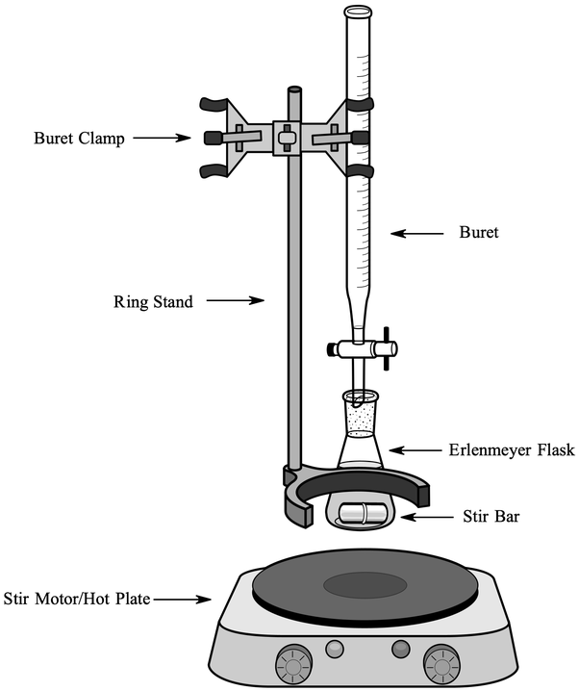

Recently over the past 50 years the reaction rate measurement and enzymatic assays principles have become the norm. The reaction rate can be defined as the change in concentration divided by the change in time [14]. This concept allowed for those chemical reaction based assays not to reach full equilibrium to make analytical conclusions. Furthermore, the introduction to flow based techniques are a completely different concept altogether. These flow based techniques is what leads us to the main concept behind the GlobalFIAs miniSIA-2 platform, the flow injection analysis.

Flow injection analysis (FIA) is a fluid analysis method involving sample injection, transport, reagent addition, reaction, and detection that can be done quickly (up to 10s of seconds quick) while remaining efficient with resources and a high level of precision [14]. Its efficiency of resources derives from FIA’s use of small tubing as small as .3 mm to promote a smooth laminar flow. Proportionally, this results in small amounts of reagents and reactants to be used in order to complete the necessary chemical reactions, increasing speed as well.

FIA involves a propulsion, injection, separation+mixing, and a detection component. Propulsion components usually consist of a pump or syringe for delivery of carrier and reagent solutions. A popular choice in early FIA development was the peristaltic pump due to its availability and multiple channels. However, the peristaltic pumps actuates using pulses, and thus as the materials wear the flow produced with the pump will reduce over time. More recently developed, the milliGAT pump, used in our project, consists of four, spring loaded reciprocating piston driven by a stepper motor. As one piston on the motor fills a port in the cylinder head of the pump, a second piston discharges through a second port. This results in an overall pulseless flow out of the pump, solving the problems of the peristaltic pump. The pump is also reversible in direction allowing it to both aspirate and dispense. The milliGAT pump delivers flows from nanoliters/min to milliliters/min [14]. The pump works to move fluid throughout the system, using both aspiration and dispensing to perform the necessary reactions by moving the sample or chemical into the proper mixing chamber.

The injection component of our study consists of a rotary valve. Early models used a septum and syringe to inject samples into the system. The need for high-precision and automation led to the development of the rotary valve which is driven by stepper motors The rotary valve utilizes time based injection, which is pumping through a manifold at a known flow rate for a defined period. This allows injection volume to be varied by altering the time a valve is open. This allows different fluids to be used as timing would just need to be changed to accommodate for different mechanical properties. However, any external disruptions to flow rate will greatly affect the reproducibility of the process, meaning error handling will be necessary [14]. This component can control the piping system of the process and can connect necessary valves and containers, switching between samples and necessary chemicals for the process.

The separation+mixing component of our study consists of a PTFE coiled tubing. PTFE is used because of its chemically unreactive property. Due to the small internal diameter of the tubing, laminar flow is maintained throughout the system. The coiled portion prompts radial mixing of the reagents and reactants as the fluids flow in a radial motion through the coil. If a small enough coil radius is used, secondary flow is induced and promotes the radial mixing. Using two coils, it is possible to mix between them as well as transport fluids from one to the other. The coils act as a zone for chemicals to mix and keep them separated from the rest of the system until it is necessary to proceed with the process [15].

The detection component uses a sensor for measurement of change in a variety of properties including fluorescence, infrared absorption, pH, or, in our case, absorbance. The project uses a spectrophotometer, a device that measures concentration of a substance in a solution by passing a light through the substance and measuring light intensity as a function of wavelength [16]. This requires a base reading for reference and the absence of air bubbles that can reflect the light shining into the substance. The FIA system, after completing the mixture of chemicals and sample, moves the mixture into a tube where light is shining on one end, through the tube, and into the spectrophotometer. The spectrophotometer records the data measured and from it the concentration of a target substance can be determined.

FIA combines all these components to develop a way to perform fluid analysis efficiently and quickly. From the precision of the pump, small and precise amounts of chemicals and samples can be used resulting in faster reaction times while maintaining accuracy. The injection component regulates the flow of the fluids throughout the system into the separation, mixing, reactants, and reagent components. Finally, the detection component takes the measurements necessary for analysis of the concentration of the target substance.

# 

# Chapter 3

## Design Overview

The design of the instrument is mostly decided as the changes to the previous version are external to the packaging of the nutrient analyzer. However, the functionality of the components used by the MLML is such that the existing controller board does not benefit the autonomization of the instrument. It was discovered while researching the pump and servo valve datasheets that the current controller board communicates with the pumps and servo in a way a microcontroller can emulate. The option of using the microcontroller to emulate the laptop computer that communicates with the controller board used in the previous instrument adds a level of complexity to the project and provides additional points of failure.

The current design does not incorporate the controller board used in the previous instrument. This reduction of parts significantly reduces the overall cost of the instrument, as well as lowers the barriers to entry of building one. It would be easier to build the instrument using the controller board, there is an established and documented method for doing so as it is a product supported by the manufacturer for this specific purpose. However, the use of the controller board does benefit the functionality of the instrument and it aligns with the ethical goals of the project to not use it

## Enclosure and Housings

### Figure 3

#### Proposed enclosure for instrument

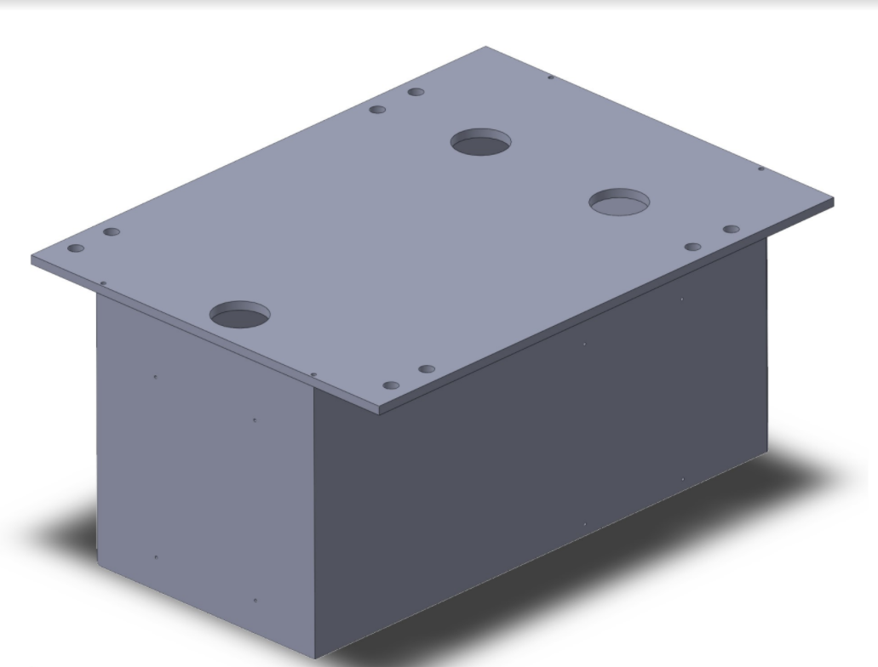

Finding space in the previous design for a small microcontroller is a reasonable accommodation. Changes to the enclosure for portability and waterproofness are suggested by our team and have yet to be finalized by the MLML. A nested secondary enclosure for the microcontroller is suggested to ensure the longevity of the instrument. Ideally the space created by eliminating the controller board should provide ample room for the microcontroller and a secondary enclosure. When considering enclosure designs it’s important to acknowledge the environment the module will be exposed to. MLML uses this instrument in a marine environment where salt water is prevalent and specific considerations need to be made. In this environment galvanic corrosion is prevalent, the high moisture content contributes to this as well as shortening the lifespan of electronics exposed to it. In figure (3) above the current design is shown for the primary enclosure. In the following image the housing design for the pumps and servos can be seen inside the enclosure.

### Figure 4

#### Pump fixtures inside the enclosure

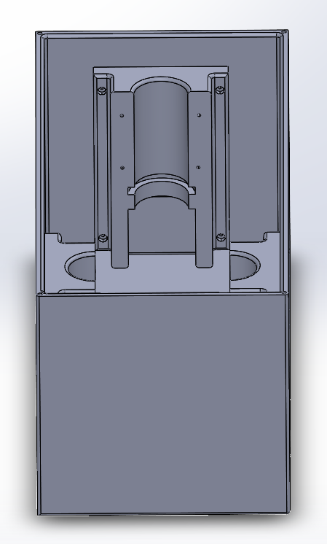

## Mechatronic Systems

At the center of this iteration’s design changes is a microcontroller (MCU). This MCU will be managing the mechanical system of light source, spectrometer, feedback sensors, pumps and servo used in to process and measure the assay. There are many microcontrollers that fit the parameters of operation needed. Further research and expert consultation is needed prior to finalizing the choice of MCU as we’re not sure without testing the rate at which a microcontroller will process the calculations from the spectrometer. An additional design change is the addition of wireless communication and data logging. Should the data processing be found to take longer than the cycle time of a sample, an additional microcontroller will be used to process the sampling, data collection, wireless communication and user interface. This MCU will be the primary control of the system and will communicate via I2C with the secondary MCU that controls the mechanical processes. This will allow for rapid prototyping and a means to estimate how much more computer we will need than running one MCU.

### Figure 5

#### Circuit diagram of mechanical control system

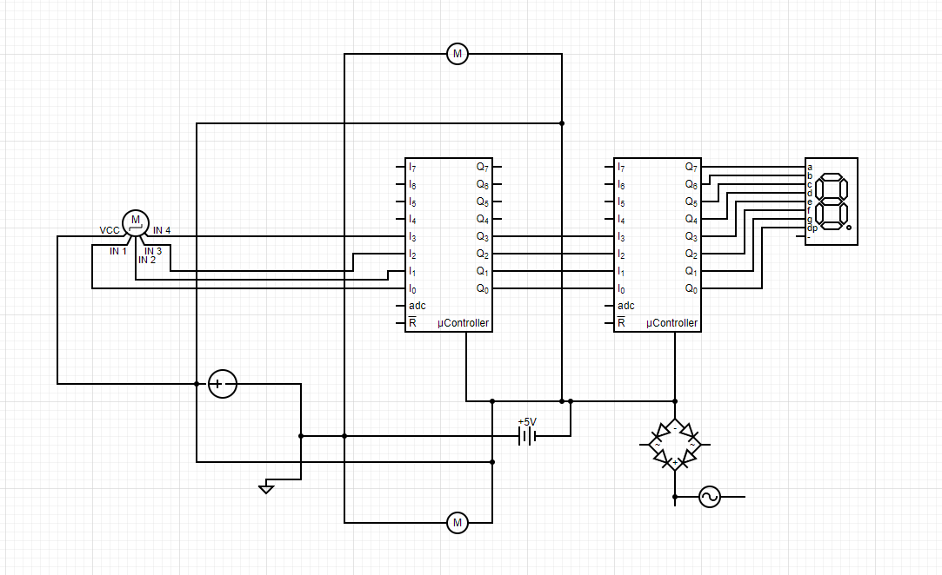

The above figure shows the circuit diagram for the mechatronic system controls. It shows the proposed use of two MCU’s to separate the tasks of controlling the mechanical process of the assay and the calculations of determining the sample’s concentration levels. The feedback systems for ensuring the process does not get contaminated are planned to be as follows. First and foremost a sensor to stop the cycle before any of the chemical compounds runs out. Secondarily, a small backup power supply of an estimated 1 watt hour in order for the instrument to be able to flush the holding coils and servo valve in order to preserve the sample and not contaminate the device. If possible a tertiary feedback for signaling when a sample is out of the expected range to notify the user of a potential problem with the system.

# Chapter 4

# 

## Testing Results and Analyses

The current testing into establishing communication between the pumps/servo and the microcontroller has yet to provide a conclusive answer to the question of bypassing the controller board from the previous iteration of the instrument. A major set back has been finding the wiring diagram provided by the hardware manufacturer to be misaligned with the wiring on the actual hardware we have. Because of this, we have been unable to determine if the controller board can be bypassed. The team has had to further research the process of packet sniffing of a local network system to understand which wire is doing which communication. Furthermore we have yet to receive the equipment from our sponsor. Our scheduled visit is December 17,2021, where we will collect the needed supplies to begin the integration process.

## Conclusions and Future Work

In order to accomplish the objectives, our team intends to use a python based microcontroller to operate each component and record data. The target is to have a python program that calls functions to send digital signals to the pumps when necessary. Assuming possible , the pumps will be programmed with its house software to perform controlled aspirating or dispensing depending on the digital signal received at the corresponding digital io pin. The rotary valve motor can be programmed to move to the necessary positions to control the flow direction between the pump and reagents/reactants. The functions in the python will include calls to the motors of pump 1, pump 2, and the rotary valve to actuate them. By having the majority of the programming done to the pumps, the size of the microcontroller program can be kept low and simple resulting in faster run time, controller power efficiency , and lower system requirements.

The python program will receive inputs from the spectrophotometer and store the values in a time series. The team will work with a CMPE division to have the analyzer communicate wirelessly with the MLML computers. Ideally, sensors will be connected to monitor levels of the sample and reagents. Using this data, it is possible to create a function to indicate if any substance needs to be refilled. In order to compute and handle the information optimally, the microprocessor should be adequately sized, yet should keep as many benefits of the previous paragraph.

To handle errors, the python program will have a flush function in which the whole system is flushed with deionized water and the positions of all motors are reset to prepare the system for a rerun. Ideally, motor position will be reset as little as possible in the programs to preserve run speed and power usage while maintaining accuracy and reproducibility.

## Description

This project’s aim is to design and construct a nutrient analyzer that will sample ocean water from a continuous source every hour for thirty days. The process of measuring for nutrients requires deionized water and reagents ascorbic acid, molybdate, mixed and measured at specific ratios and times. The measurement is made using a spectrometer so the device must be flushed between measurements to ensure accuracy of results.

Absorbance is scalar units because it is a value with respect to another measurement, this is essential to taking measurements using a process such as this that is time and temperature sensitive. With this set up, the spectrophotometer is calibrated each using a sample of a known concentrate and flushed using deionized water.

The priority of the project is to obtain precision motor control through a microcontroller. The objective is to synchronize the action of the motors and control flow rates to precisely mix the reagents. Following this, the next objective will be to mix the chemicals with the sample water and pump the mixture into a flow tube where the spectrophotometer will measure the light going through the mixture. This will give a reading in which the lab can use to measure the amount of nutrients in the sample. Following the successful data acquisition, the system must be flushed with water in order to prevent inaccurate measurements and contamination.

### Figure 6

#### Benchtop setup while in operation

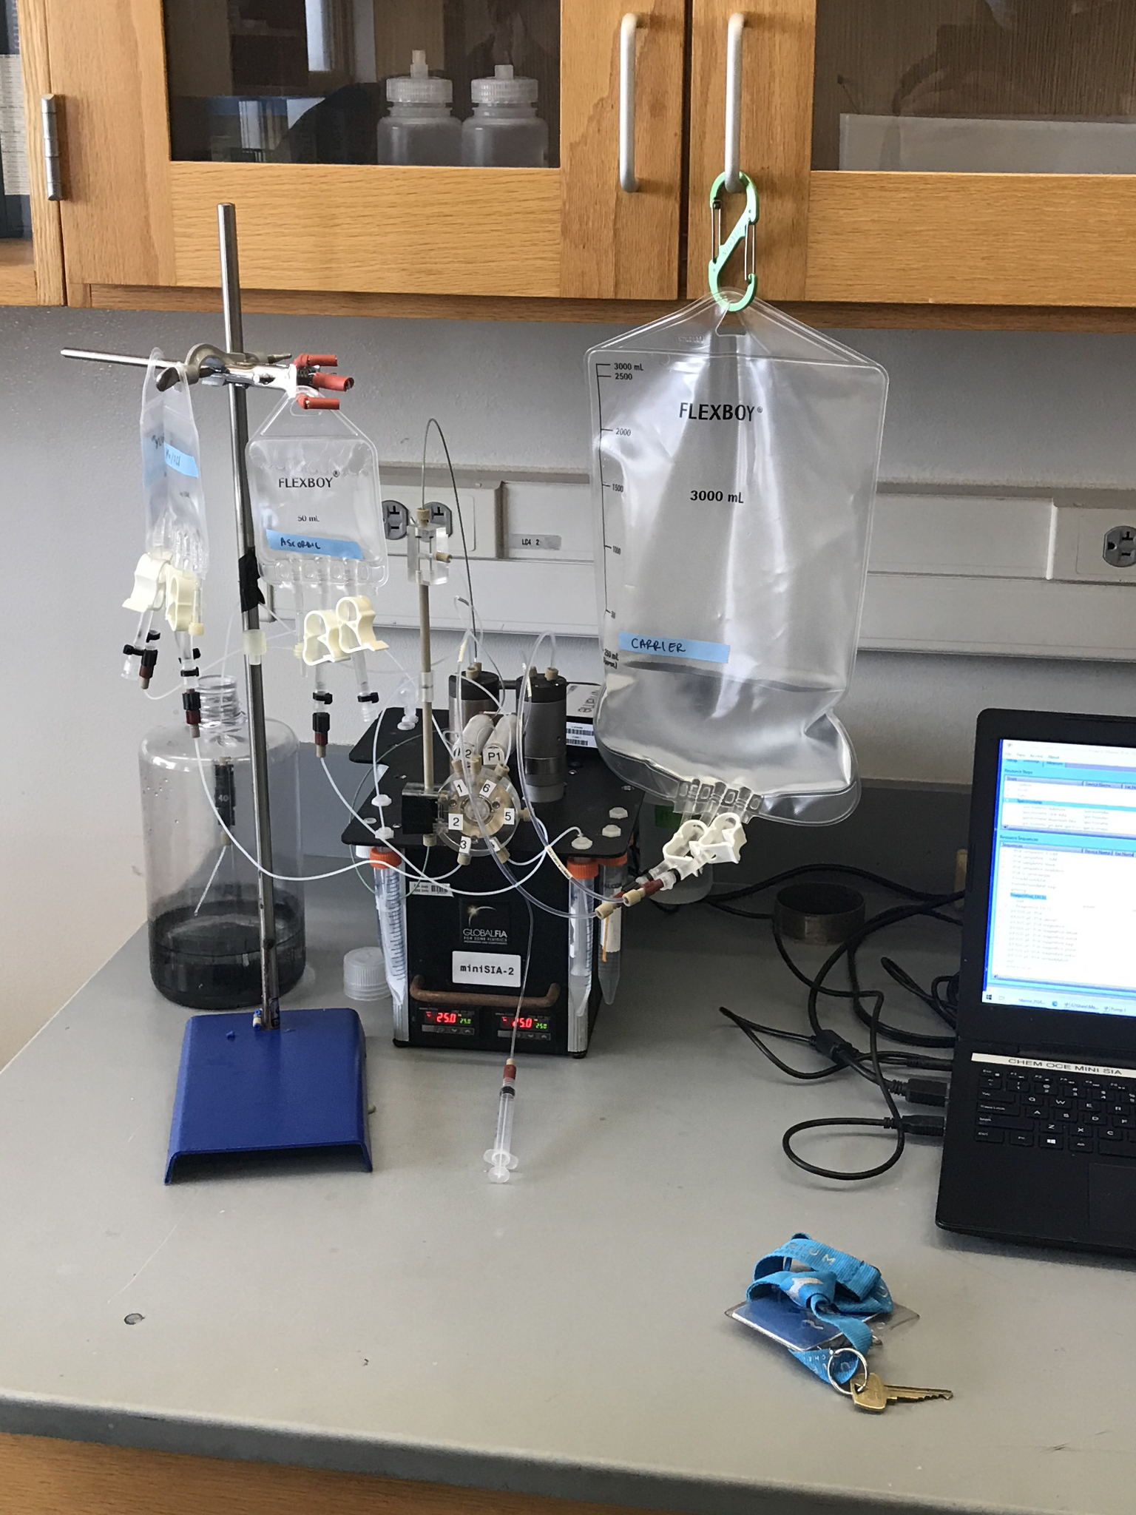

The primary system consists of two holding coils, each connected to a motor to act as a pump to both aspirate and dispense. The pumps connect directly to a deionized water reservoir as well as the holding coil. The other end of each holding coil is connected to a rotating piping system that allows the pump to aspirate from a variety of fluids including molybdate, ascorbic acid, and the sample. A short description of the target procedure is as followed:

1) The system will perform a flush with deionized water to ensure that remaining chemicals are washed out.’

2) The rotating assembly will connect pump/holding coil 1 to reagent 1 and aspirate x amount of the reagent.

3) The rotating assembly will connect holding coil 2 to reagent 2 and aspirate x amount of reagent. Simultaneously, the rotating assembly should have holding coil 1 and 2 connected and pump the reagent 1 in coil 1 to coil 2 to mix the chemicals.

4) The rotating assembly will connect holding coil 1 to the sample and aspirate x amount of the sample. Simultaneously, the assembly should have holding coil 1 and 2 connected and pump the mixture from coil 2 into coil 1.

5) The rotating assembly will connect holding coil 1 to the flow tube and pump the final mixture into the tube.

6) The spectrophotometer will make measurements over a set amount of time to ensure stable readings and store the data.

7) The system will perform a flush

Key elements of the programming include ensuring the proper amounts of each fluid are aspirated and that the reagents are continuously insulted with DI. Additionally, the pumps must be synchronized to prevent pumping unintended fluids into the reservoirs creating contamination. The pumps must also be precise so that the proper chemical reaction will occur.

### Figure 7

#### Graphic user interface for controller pump speed and output from absorbance value time series taken in

#### real time.

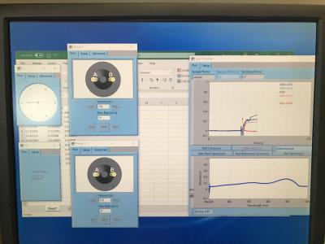

# Deliverable(s)

By the end of this project we are looking forward to demonstrating a much deeper understanding of the technical steps needed to accomplish our long term goal. This will include gaining further insight into the impacts of this technology; from the perspective of culture, society, economics, politics and as well as other fields. Considering the ramifications of implementing technology into society is an important step engineers need to take. Coupling this with detailed steps needed to achieve our long term deliverable goals will set us up for success. Documentation of steps taken already will leave us in a very knowledgeable position with the ability to make conscious design decisions moving into the later stages of the design project. Explicit steps we plan on accomplishing by the end of this semester will be the following:

* Acquire all necessary proprietary components, and software courtesy of Moss Landing Marine Laboratories. This should ideally be done by late October.
* Determine and acquire the microcontroller of choice, and begin developing the software for operating the bench top set up. We have selected to operate the analyzer with a microcontroller, using the language Python to communicate with the lab set up. This will be broken up into individual components and tackled by individuals in the group. Joint discussion and collaboration is a guarantee.
* Begin light drafting of housing apparatus for analyzer set up.
* Continue to research the ramifications of this technology
* By the end of spring 2022 we have a clear deliverable.

**We are designing and manufacturing a phosphate nutrient analyzer for measuring seawater based on open source coding and using a microcontroller to implement the steps required for achieving this outcome.**

This includes several requirements:

* A python program running off of a microcontroller that operates the lab set up independent of user input, measuring and acquiring data every 30 minutes for 30 days.
* The program will have built in fail stops for when reagent levels are low. Will be capable of executing a self flush operation when bubbles are detected.
* A waterproof enclosure that holds the reagents, samples, microcontroller, peripheral electronics. A focus on ease of operability is desired. We want users to be able to refill reagents, samples, and transfer data from the microcontroller with ease. We do not plan on creating an illusive blackbox.

Discussion on taking this project further postgraduatation has been discussed. While the concept we are developing is not novel, nor the chemistry proprietary, as a group we collectively agreed to making this instrument open source. The demand for similar instruments is not known; how we all want to move forward with it outside of a classroom setting is still being discussed.

# 

# 

# 

# 

# 

# 

# 

# References

[1] *MBNMS Resource Issues: Ecosystem Conservation and Biodiversity Protection*. (n.d.).

Montereybay.noaa.gov. Retrieved September 25, 2021, from <https://montereybay.noaa.gov/resourcepro/resmanissues/biodiversity.html>

[2] USGS. (n.d.). *Phosphorus and Water*. Usgs.gov.

<https://www.usgs.gov/special-topic/water-science-school/science/phosphorus-and-water?qt-science_center_objects=0#qt-science_center_objects>

[3] Hallegraeff, G. M. (1993). “A Review of Harmful Algal Blooms and Their Apparent Global

Increase.” Phycologia, <https://doi.org/10.2216/i0031-8884-32-2-79.1>.

[4] *Monterey County Farm Bureau - Facts, Figures & FAQs*. (n.d.). Montereycfb.com.

<http://montereycfb.com/index.php?page=facts-figures-faqs>

[5] *Nutrient analysers - Coastal Wiki*. (n.d.). Www.coastalwiki.org. Retrieved September 25,

2021,<http://www.coastalwiki.org/wiki/Nutrient_analysers#:~:text=A%20variety%20of%20wet%20chemical%20nutrient%20analyzers%20exist>

[6] *Phosphorus and Your CKD Diet*. (2018, November 2). National Kidney Foundation.

<https://www.kidney.org/atoz/content/phosphorus>

[7] *Nutrient analyzers and sensors*. (n.d.). Www.endress.com. Retrieved December 01, 2021,

<https://www.endress.com/en/field-instruments-overview/liquid-analysis-product-overview/nutrient-analyzers-sensors#:~:text=Nutrient%20analyzers%20and%20sensors%20are%20used%20in%20the>

[8] *Systems: miniSIA-2*. (n.d.). Www.globalfia.com. Retrieved December 01, 2021, from

<https://www.globalfia.com/store/view/productdetails/virtuemart_product_id/200/virtuemart_category_id/7>

[9] Ibnul, N. K., & Tripp, C. P. (2021). A solventless method for detecting trace level phosphate

and arsenate in water using a transparent membrane and visible spectroscopy. *Talanta*

*(Oxford)*, *225*, 122023–122023. <https://doi.org/10.1016/j.talanta.2020.122023>

[10] Legiret, F.-E., Sieben, V. J., Woodward, E. M. S., Abi Kaed Bey, S. K., Mowlem, M. C.,

Connelly, D. P., & Achterberg, E. P. (2013). A high performance microfluidic analyser for phosphate measurements in marine waters using the vanadomolybdate method. *Talanta (Oxford)*, *116*, 382–387. <https://doi.org/10.1016/j.talanta.2013.05.004>

[11] Jarda Ruscika. (2021). *Flow Injection Tutorial*. Flowinjectiontutorial.com.

<https://www.flowinjectiontutorial.com/Theory%200.1.1.%20Introduction%20-%20From%20Batch%20to%20Flow%20Based%20Analysis.html>

[12] *Gravimetric Analysis Principle with Types, Advantages and Examples*. (n.d.). BYJUS.

Retrieved December 01, 2021, from <https://byjus.com/chemistry/gravimetric-analysis/#:~:text=The%20principle%20of%20Gravimetric%20Analysis%3A%20The%20principle%20behind>

[13] *Titrimetry - an overview | ScienceDirect Topics*. (2019). Sciencedirect.com.

[https://www.sciencedirect.com/topics/chemistry/titrimetr](https://www.sciencedirect.com/topics/chemistry/titrimetry)

[14] 2.5: Reaction Rate. (2013, October 2). Chemistry LibreTexts.

<https://chem.libretexts.org/Bookshelves/Physical_and_Theoretical_Chemistry_Textbook_Maps/Supplemental_Modules_(Physical_and_Theoretical_Chemistry)/Kinetics/02%3A_Reaction_Rates/2.05%3A_Reaction_Rate#:~:text=The%20Reaction%20Rate%20for%20a%20given%20chemical%20reaction>

[15] Principles of Flow Injection Analysis. (2020, January) Researchgate.

[https://www.researchgate.net/publication/338435099_Principles_of_Flow_Injection_Ana](https://www.researchgate.net/publication/338435099_Principles_of_Flow_Injection_Analysis)

[lysis](https://www.researchgate.net/publication/338435099_Principles_of_Flow_Injection_Analysis)

[16] Spectrophotometer. N.D. labcompare.com

<https://www.labcompare.com/Spectroscopy/106-Spectrophotometer/>

‌

# Appendices

## **Appendix A**: Gantt Chart

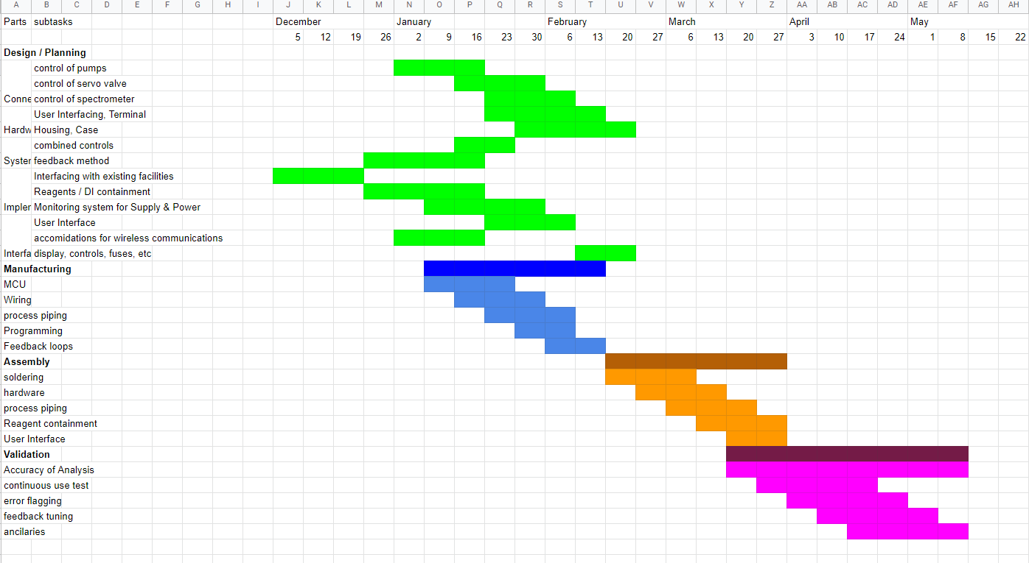

## Appendix B: Various Elements of Benchtop version

### Figure 8

#### A picture showing the holding tube for spectrometer analysis

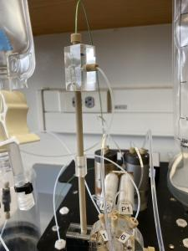

### Figure 9

#### Top view of the instrument showing the two pumps and holding coils wrapped around aluminum cylinders*.*

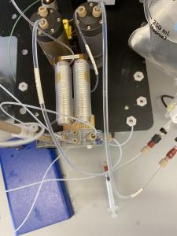

### Figure 10

#### Front view of apparatus depicting the servo driven multiport valve.

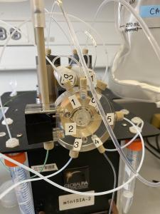

### Figure 11

#### Side view showing mounting of pumps and rotary valve.

